7 | 

#DontStopTheMusic

Check out the latest artists set to deliver live performances to your home

Sydney/Wedemark, April 7, 2020 – Sennheiser’s #DontStopTheMusic series continues with Alexander Knappe (who joins the already announced Sublime with Rome on Tuesday), Alysha, Spencer Barnett, Emily Laing, LEW, Split the Dealer, Claud, MACKandgold, Hektor Mass, DJ Lord Issa and Chris Scholar. A big thank you to the artists and their teams!

Live concert streams from Wednesday, April 8 to Wednesday, April 15
Please follow @sennheiser on Instagram and switch on notifications in IGTV to receive alerts, as dates and artists may be subject to change at short notice.
- Alexander Knappe (@alexanderknappe):
Tuesday, April 7 at 17:00 UTC (Wednesday, April 8 at 3:00 a.m. AEST)
- Alysha (@alisha_gr):
Wednesday, April 8 at 18:00 UTC (Thursday, April 8 at 4:00 a.m. AEST)
- Spencer Barnett (@spencerbarnett):
Wednesday, April 8 at 19:00 UTC (Thursday, April 9 at 5:00 a.m. AEST)
- Emily Laing (@emily_laing_uk):
Thursday, April 9 at 19:00 UTC (Friday, April 10 at 5:00 a.m. AEST)
- LEW (@lewloh):
Friday, April 10 at 14:00 UTC (Saturday, April 11 at 12:00 a.m. AEST)
- Split the Dealer (@splitthedealer):
Friday, April 10 at 19:00 UTC (Saturday, April 11 at 5:00 a.m. AEST)
- Claud (@claud.mp3):
Saturday, April 11 at 19:00 UTC (Sunday, April 12 at 5:00 a.m. AEST)
- MACKandgold (@mackandgold)
Sunday, April 12 at 19:00 UTC (Monday, April 13 at 5:00 a.m. AEST)
- Hektor Mass (@hektormass ):
Monday, April 13 at 19:00 UTC (Tuesday, April 14 at 5:00 a.m. AEST)
- DJ Lord Issa (@djlordissa)
Monday, April 13 at 20:00 UTC (Tuesday, April 14 at 6:00 a.m. AEST)
- Chris Scholar (@chrisscholar):
Tuesday, April 14 at 19:00 UTC (Wednesday, April 15 at 5:00 a.m. AEST)

* A note on the time zones - the concert times are given in Coordinated Universal Time (UTC), with AEST added for convenience.

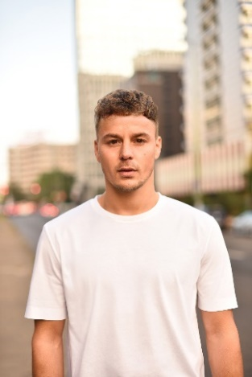 |  | 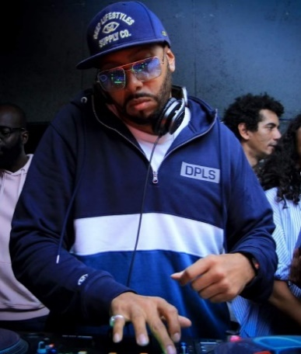
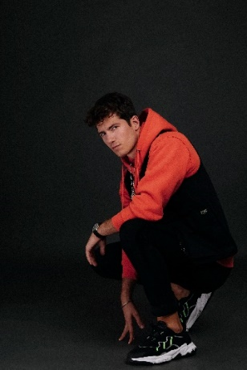 | 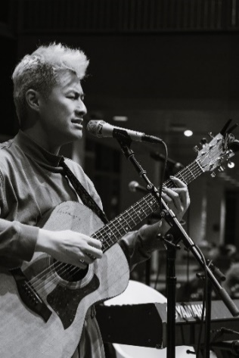

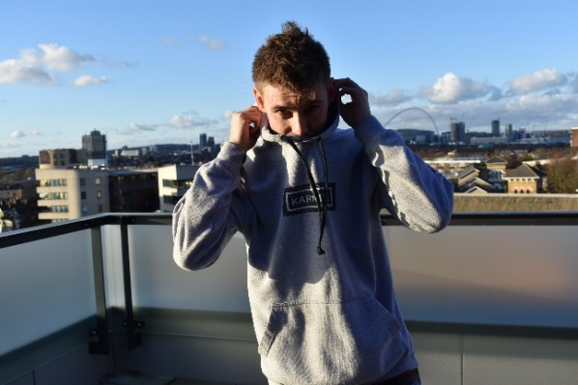 | 
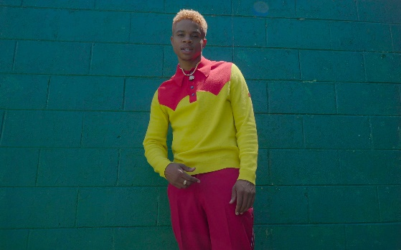

More music
Please also check out http://www.sennheiser.com/anniversary for the next livestream dates and a great selection of music videos to watch and listen to. Just put on your headphones (or turn up the speakers) and immerse yourself in immersive jazz club recordings, electro sets, or live takes from recording studios.

It’s free but why not donate to fight the coronavirus?
At Sennheiser, we’re delighted to be working with these fantastic artists to help spread positivity by putting on exclusive concerts. They’re totally free, but if you do want to say thank you, do consider supporting the WHO in its fight against the coronavirus:
https://www.who.int/emergencies/diseases/novel-coronavirus-2019/donate

For your social media channels:
Enjoy your favorite artists at home and check out the exclusive concerts in Sennheiser’s (@sennheiser) streaming concert series – live on Instagram! #DontStopTheMusic

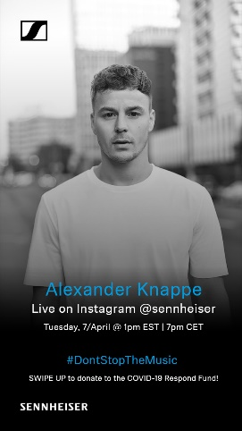 | 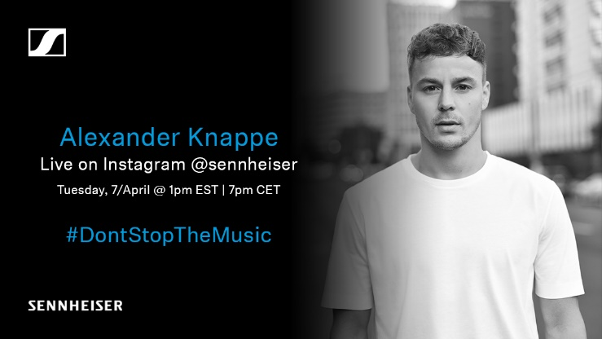
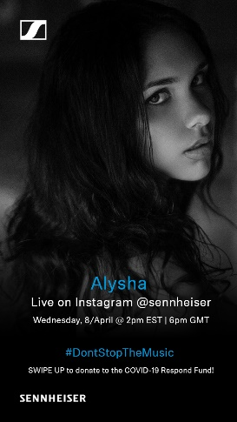 | 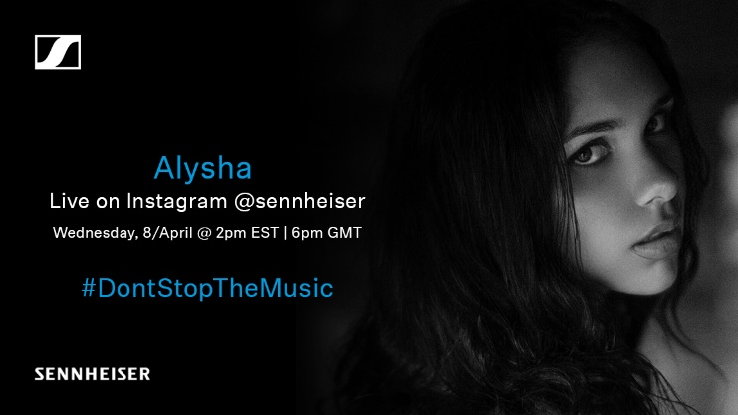
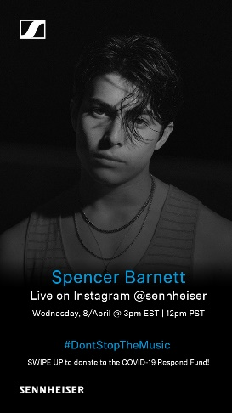 | 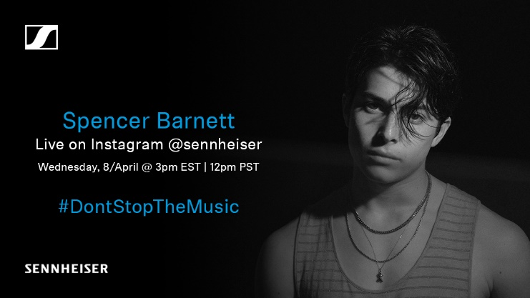
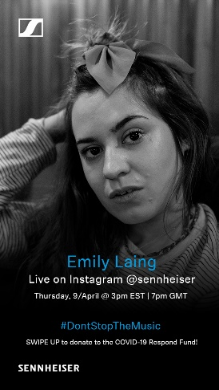 | 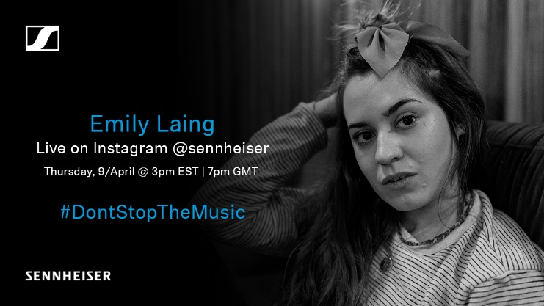
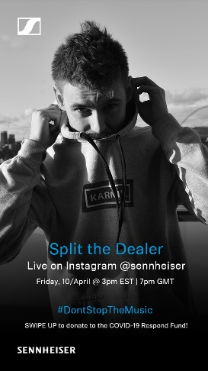 | 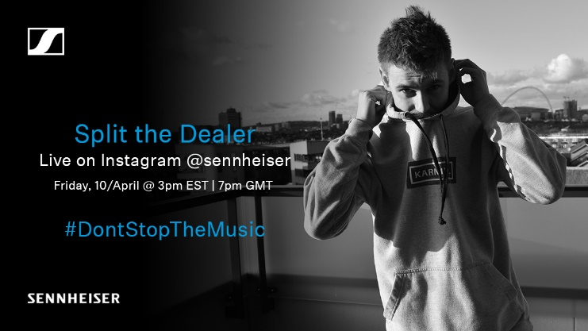

The artist images accompanying this press release can be accessed here: https://sennheiser-brandzone.com/c/181/ifCTr9Yu.

About Sennheiser
Founded in 1945, Sennheiser is celebrating its 75th anniversary this year. Shaping the future of audio and creating unique sound experiences for customers – this aim unites Sennheiser employees and partners worldwide. The independent family company, which is managed in the third generation by Dr. Andreas Sennheiser and Daniel Sennheiser, is today one of the world’s leading manufacturers of headphones, loudspeakers, microphones and wireless transmission systems. In 2018, the Sennheiser Group generated turnover totaling €710.7 million. www.sennheiser.com

Global Press Contacts

Mareike Oer Stephanie Schmidt
mareike.oer@sennheiser.com stephanie.schmidt@sennheiser.com
T +49 0(5130) 600 – 1719 T +49 0(5130) 600 – 1275

Local Press Contact
Gabby Wallace
gabby.wallace@hausmann.com.au
T 0431 045 932

